PRESIDENT’S DAY
SATURDAY 11THMAY 2PM
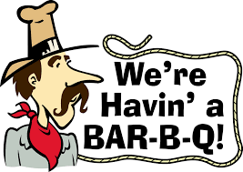Come along and have an enjoyable afternoon of bowls followed by burgers, hot dogs – and choc ices.
There will be a mixed 15 ends triples match between the President’s and Vice President’s Teams.
The afternoon will start with an “alternative spider” 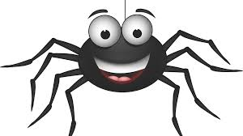 (details on the day!) £1 entry fee. Winning prize will be a £10 voucher for the club bar with the remainder being shared between the two Captains’ charities.
It will conclude with a “corner to corner” challenge. £1 per attempt. Winning prize will be 50% of money taken with the remainder, once again, being shared between the two Captains’ charities.
NOTE: Dress can be of your choice except

CLOSING DATE: Monday, 29th April

