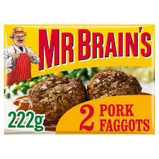 BRING YOUR BRAINS TO 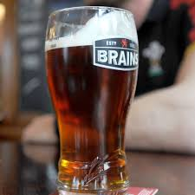
DAVE’S QUIZ
TUESDAY 9TH NOVEMBER 7PM START
WILL IT BE A CASE OF “IT’S ALL GREEK TO ME”
OR WILL YOUR TEAM HAVE A EUREKA MOMENT!
COME ALONG AND TEST YOUR KNOWLEDGE IN A FRIENDLY SOCIABLE ATMOSPHERE
NO NEED TO BOOK. JUST TURN UP WITH YOUR TEAM, GRAB A DRINK AND ENJOY YOURSELF
MAXIMUM OF SIX PER TEAM £1 PER PERSON
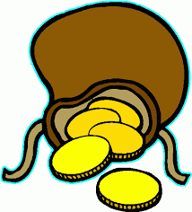 THE MORE THAT ENTER THE BIGGER THE PRIZE

